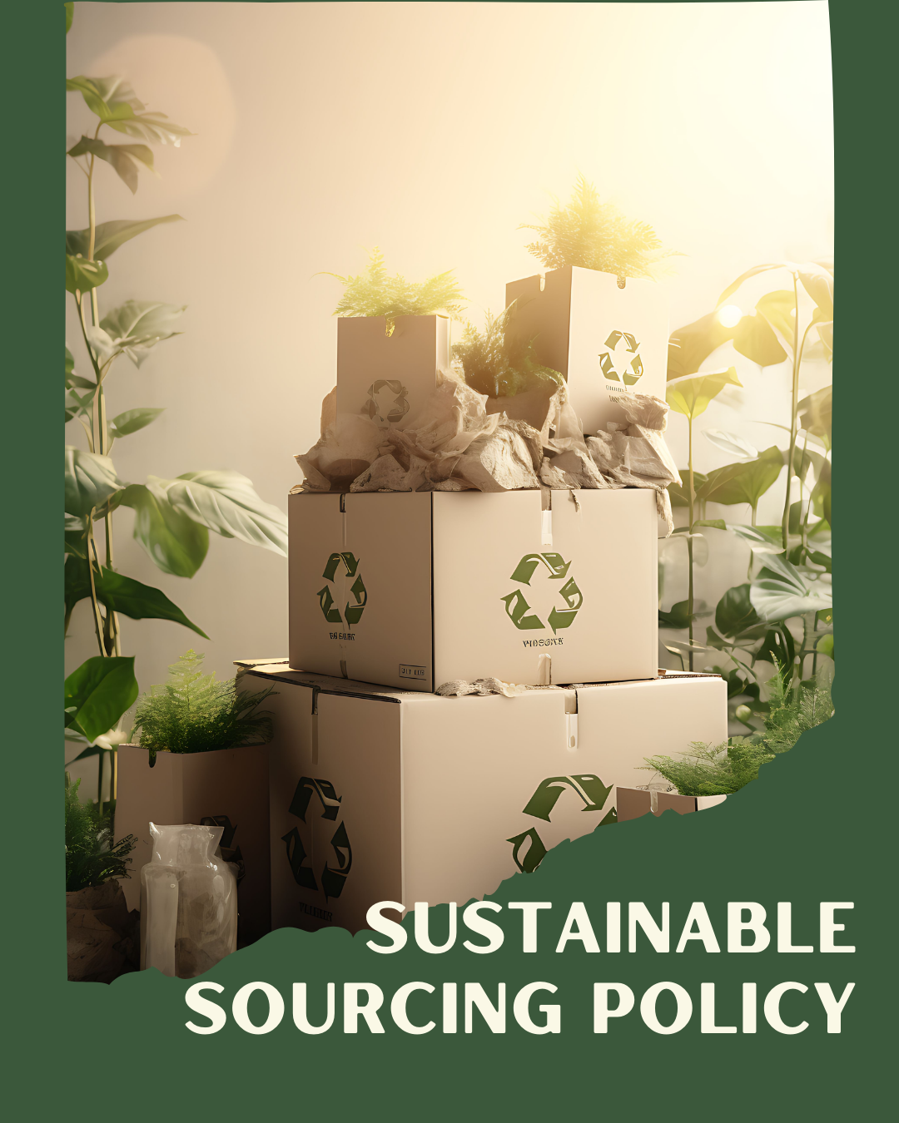
ARSH FASHIONS PVT. LTD.

A UNIT OF PERMESHWAR FASHIONS IMPEX PVT. LTD.

TABLE OF CONTENTS
PREFACE 2
SCOPE 2
POLICY DECLARATION 2
INITIATIVES AND TARGETS IN ALIGNMENT WITH SDGs 3
PERFORMANCE REPORTING 4
REVIEW MECHANISM 4

PREFACE

At Arsh Fashions, sustainability is integral to our commitment to responsible business practices. Our Sustainable Sourcing Policy outlines our dedication to procuring materials and services that uphold environmental stewardship, ethical standards, and social responsibility. This policy establishes clear guidelines for sourcing decisions, ensuring that our supply chain aligns with our sustainability goals and industry standards. By implementing this policy, we aim to reduce our environmental footprint, promote fair labor practices, and support sustainable development, thereby reinforcing our position as a leader in ethical and eco-conscious garment production.

SCOPE

This Policy is applicable to following sites and all of its employees, workers, sub-contractors and other stakeholders:

Sr. No. | Site | Address
1 | ARSH FASHOINS Pvt. Ltd. | Plot No.194, IInd Phase, G.I.D.C., Vapi - 396195,  Gujarat, India.

POLICY DECLARATION

Arsh Fashions is committed to a Sustainable Sourcing Policy that prioritizes environmental stewardship, ethical labor practices, and social responsibility. This policy ensures that all materials and services are sourced sustainably, minimizing environmental impact and promoting fair treatment throughout our supply chain. We aim to support sustainable development and uphold our core values, aligning our sourcing practices with our long-term organizational goals. Our baseline year for measuring progress in sustainable sourcing practices is 2023

INITIATIVES AND TARGETS IN ALIGNMENT WITH SDGs
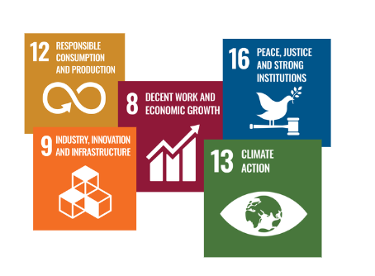

- Establish partnerships with suppliers who have strong environmental policies and practices in place.
- Achieve a 20% reduction in carbon emissions from sourced materials by year 2030..
- Implement a system for full traceability of all key materials from origin to final product.
- Ensure 100% of suppliers are mapped and audited for compliance with transparency standards by year 2030.
- Develop and enforce a supplier code of conduct that ensures fair labor practices and respect for human rights.
- Conduct regular annual audits of 90% of suppliers to verify compliance with labor and human rights standards by year 2030.
- Promote the use of recycled and biodegradable materials within the supply chain.
- Increase the percentage of recycled materials used in production by 25% by year 2030.

PERFORMANCE REPORTING

Performance reporting for the Sustainable Sourcing Policy will be conducted annually, reviewing our progress on the sustainability initiatives. The report will assess our efforts to partner with environmentally responsible suppliers, reduce carbon emissions, and improve supply chain traceability. It will evaluate compliance with our supplier code of conduct on labor and human rights and detail our advancements in using recycled and biodegradable materials in production.

REVIEW MECHANISM

The Sustainable Sourcing Policy will be reviewed annually by the Sustainability Manager to ensure its effectiveness and alignment with our goals. This process will include evaluating environmental impact metrics, verifying supply chain transparency, and ensuring adherence to ethical labor practices. The review will incorporate audit results, stakeholder feedback, and industry developments to identify and address any gaps.

REV. No. 01

EFFECTIVE FROM: 01.01.2024 NEXT REVIEW DATE: 01.01.2025
APPROVED BY: PRESIDENT - OPERATIONS

